OPERATION ACTIVE RESOLVE

SPECIAL OPERATIONS COMPONENT COMMANDER

INTELLIGENCE REPORT D4

# General Information

This intelligence report covers the last 24 hours (from SOCC units and intelligence from D4).

Last 24 hours, SOCC have inserted teams into positions requested by VIS/JFACC. Teams are in place without any issues.

# Intelligence

## SYTGT003 – 922nd SCUD Regiment base

* Late on the evening of D4, the SOCC team identified 9 vehicles leaving the base. The vehicles were: 4x SCUD TEL, 2x transports, 3x CP Ural-375. The convoy was heading EAST.

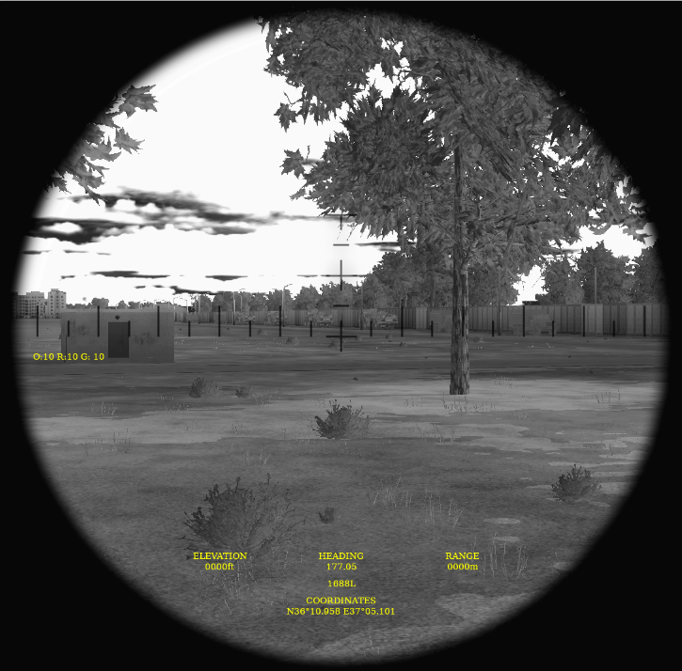

## SYTGT037 – Aleppo Airport

* NSTR (Nothing Significant To Report)

## SYTGT056 – Port Tartus

Team has identified three ship structures, see pictures below. Pictures taken from the southern part of the port.

Team has good access to watch ships coming in and out of the port, and have not seen any ships enter or leave the port during D4.

**Overview:**

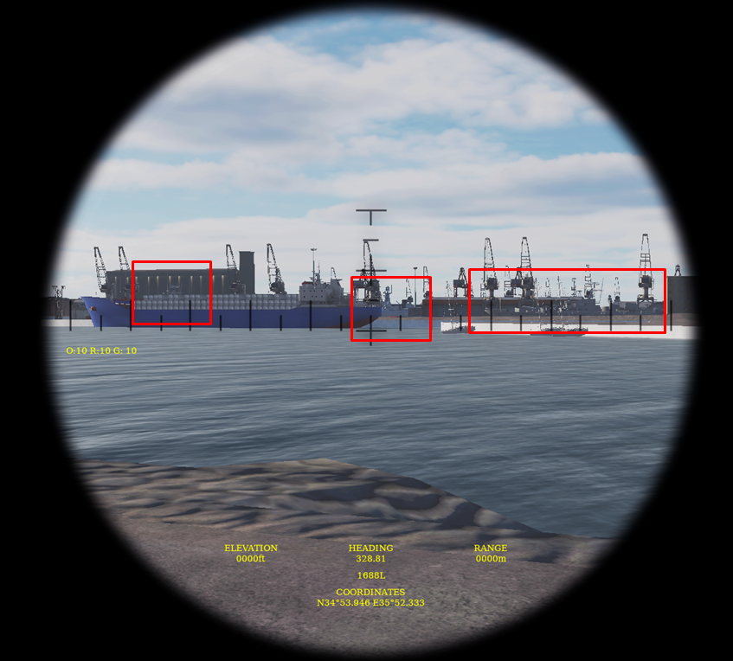

**Ship 1:**

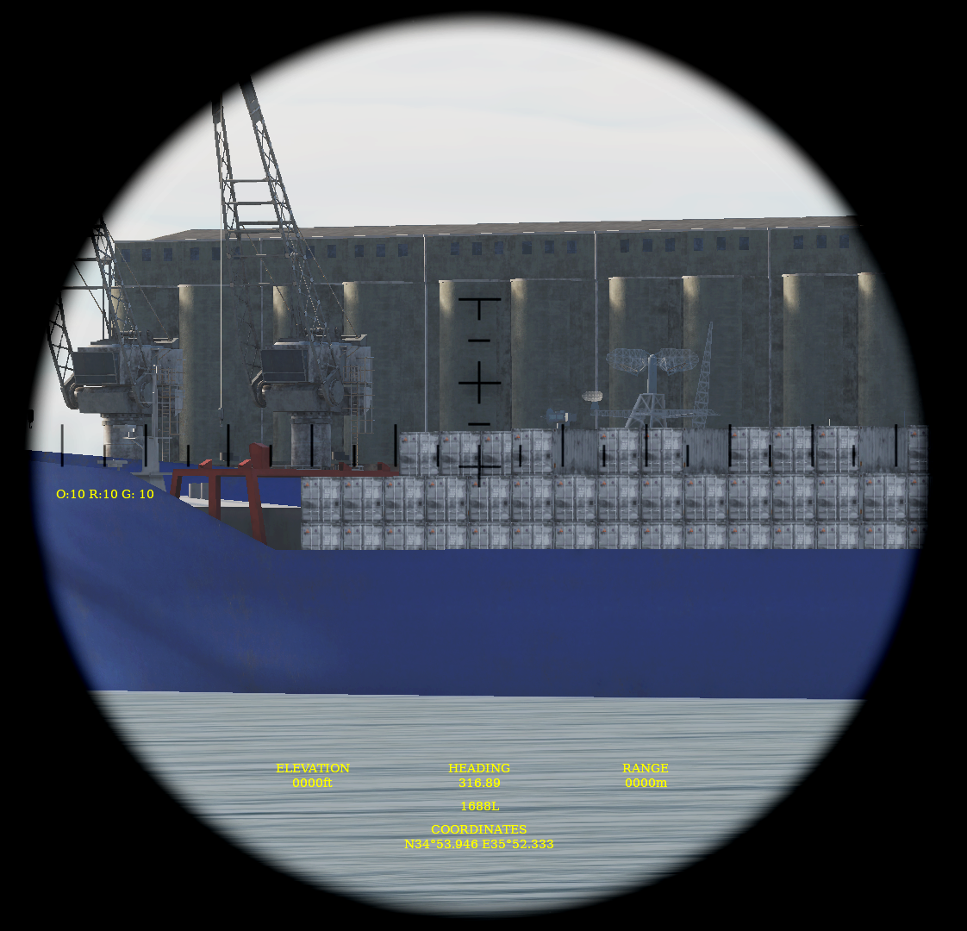

**Ship 2:**

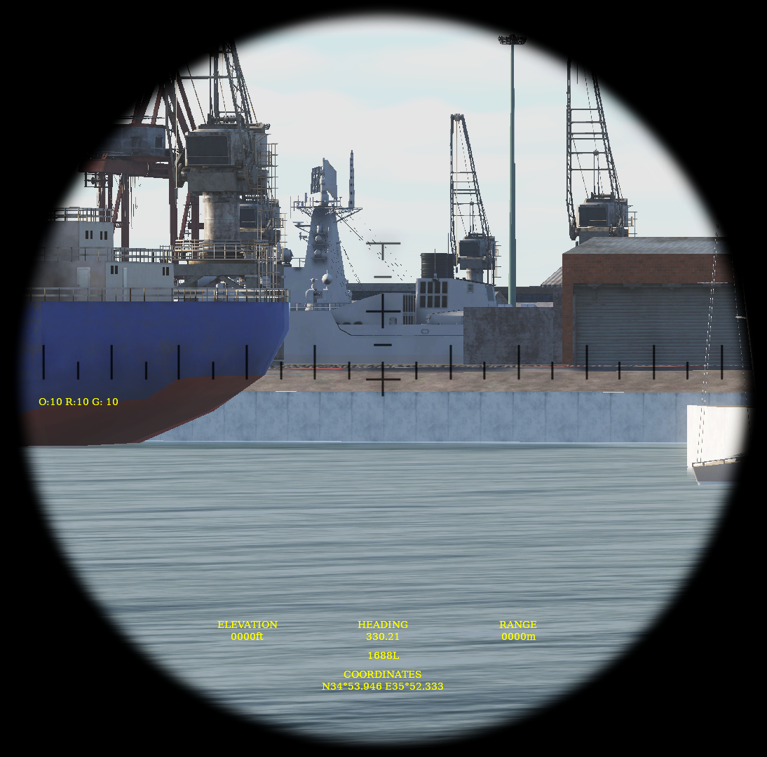

**Ship 3:**

